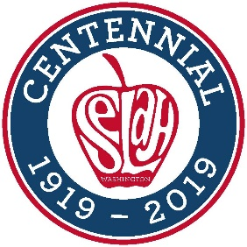
City of Selah
Consumer Confidence Report
Water Quality 2025

YOU ARE RECEIVING THIS REPORT AS PART OF A FEDERAL REPORTING REQUIREMENT FOR MUNICIPAL WATER SYSTEMS

The City of Selah Water Department is pleased to present to you Selah’s 2025 Annual Water Quality Report (2024 reporting year). This report is designed to inform you about the quality and services the City delivers. The City’s goal is to provide a safe and dependable supply of drinking water. We are committed to making improvements to the water quality process to protect our water resources, and ensure the quality of our water.

Public Participation Opportunities
Important Contacts
City of Selah Public Works
222 S. Rushmore Rd
(509) 698-7365
https://selahwa.gov/public-works/

WA State Department of Health
Office of Drinking Water
(509) 329-2100
www.doh.wa.gov

U.S. Environmental Protection Agency
Safe Drinking Water Act Hotline
(800) 426-4791
www.epa.gov/sdwa

The public is encouraged to attend and provide comment on the water system plan at the City Council meetings held on the second and fourth Tuesday of each month in the City Council Chambers, 115 W. Naches Ave. An agenda for each meeting is available at City Hall, on the web page (www.selahwa.gov/council/agenda-minutes) and at the meeting.
Any comments on how to make this report more informative, easier to read or ways to protect and conserve water are greatly appreciated.

Drinking Water Definitions
- Action Level (AL): The concentration of a contaminant, which if exceeded, triggers treatment or other requirements which a water system must follow.
- Non-Detectable (ND): Laboratory analysis indicated that the constituent is not present.
- Maximum Contaminant Level Goal (MCLG): The highest level of contaminant that is allowed in drinking water. MCLs are set as close to the MCLGs as feasible using the best available treatment technology.
- Part per million (ppm): one part per million or one milligram per liter (mg/L) is analogous to one penny in $10,000.
- Part per billion (ppb): One part per billion or one microgram per liter is analogous to one penny in $10,000,000.
- State Reporting Level (SRL): Indicated the minimum reporting level required by Washington State Department of Health.
- Variance and Exemption: State or EPA permission not to meet an MCL, AL or a TT under certain conditions.

Description of the City’s Water System
The City of Selah’s water sources come from deep wells, which are collectively capable of producing 7.5 million gallons per day. Water is yielded from the Ellensburg and Wanapum aquifers. The pumping capacity of the City’s primary wells are 5,200GPM (gallons per minute)
The City’s water reservoirs are capable of holding 3.4 million gallons of water. The existing distribution system is primarily looped and consists of mainly 8 inch or larger ductile or cast-iron water lines.

Quality Monitoring
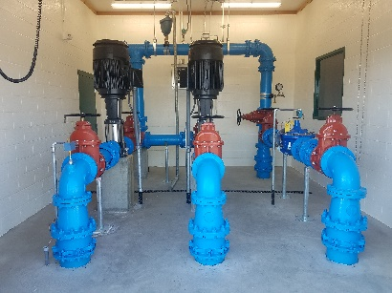
The Department of Health regulates water quality testing and monitoring schedules to ensure safe drinking water. The City of Selah is dedicated to maintaining high standards of water quality through rigorous testing of wells for contaminants such as volatile organic compounds, inorganic chemicals, nitrates, and radium. Coliform bacteria are monitored ten times per month, and lead and copper levels are tested at thirty sites across the water distribution system.
In 2023, thirty samples were taken, with no exceedances of action levels for copper or lead detected. The City has also begun testing for Polyfluoroalkyl Substances (PFAS), all of which were non-detectable.
Elevated levels of these contaminants can pose health risks, particularly for pregnant women and young children. Lead contamination in drinking water primarily originates from service lines and home plumbing materials.
*Lead in drinking water is primarily from materials and components associated with service lines and home plumbing.

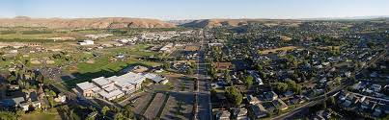
When your water has been sitting for several hours in your house plumbing you can minimize the potential for lead exposure by flushing your tap for 30 seconds to 2 minutes before using water for drinking and cooking.
If you are concerned about lead in your water you may wish to have your water tested. Information regarding testing methods, and steps you can take to minimize lead exposure in drinking water can be found from the Safe Drinking Water hotline, (800) 426-4791.
Fluoride: The wells listed below pump into the water distribution system. They do not all run at the same time so fluoride levels may vary throughout the system. The SRL for fluoride is 0.5 mg/L with a trigger level or 2.0 mg/L and a MCL of 4.0 mg/L
Well | Mg/L
#5 | .3
#6 | .26
#7 | N/D
#8 | N/D

Water Use Efficiency
An abundant supply of drinking water has always been readily available and is a basic life necessity that we are fortunate enough to enjoy. Water is an important and precious resource that everyone should help conserve. The City of Selah would like to improve and reduce the current residential use per capita by 2 gallons per household per day over the next 2-year period and to keep unaccounted for water below 10%. The City will achieve this with public outreach education, encouraging residents to practice conservation techniques, and by adding consumption history to residents’ utility billing information.
How much water does the City of Selah produce and sell?
- In 2024 the City produced 897,092,000 million gallons and sold 845,917,688 million gallons of water with 5.7% unaccounted for (new recording software implemented & remote meters)
- In 2023 the City produced 857,448,000 million gallons and sold 860,538,655 million gallons of water with 0.36% unaccounted for. (new recording software implemented &remote meters)
- In 2022 the City produced 858,782,000 million gallons and sold 833,885,158 million gallons of water with 1.7% unaccounted for.
- The three-year average of unaccounted for water is 3.7%.

What can residents do to help the City to reduce and conserve water usage?

General Health Effects
Some people may be more vulnerable to contaminants in drinking water than the general population. Immunocompromised individuals, such as persons with cancer undergoing chemotherapy, persons who have undergone organ transplants, people with HIV/AIDS or other immune system disorders and some elderly and infant can be particularly at risk of infections. These individuals should seek advice about drinking water from their health care providers. The EPA/Center for Disease Control (CDC) guidelines on appropriate means to lessen the risk of infection are available from the Safe Drinking Water Act Hotline.

Water Quality Protection
High quality, clean, safe and aesthetically pleasing water is the City’s commitment to you. We have adopted the following to ensure the drinking water consistently meets or exceeds all State and Federal regulations. The City of Selah has a Well head Protection Program and Cross Connection Program. These programs are designed to prevent contamination of groundwater before and after pumping. If you would like more information on these programs, please contact Selah’s Public Works office.
(509) 698-7365
Ty Jones, Public Works Supervisor

Water Quality Protection

Nearly 60% of a person’s household water footprint is comprised of water for lawn and garden maintenance.
- A timed sprinkler system, lawn aeration and lawn fertelizers can help improve your lawn while conserving water.
- Using a water efficient dishwasher with full loads.
- It takes about 70 gallons of water to fill a bathtub, so showers are generally the more water efficient way to bathe.
- Repair water leaks in and outside of the home.
- Replace leaky toilets, faucets and other bathroom fixtures with new water efficient fixtures.

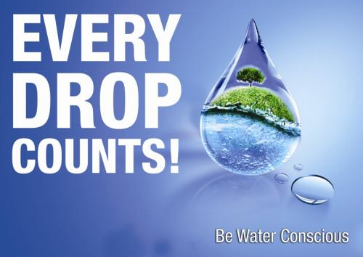

Translations
This report contains important information about your drinking water. You may wish to have this information translated.
Este informe contiene informacion importante sobre su agua potable. Es possible que desee tener esta informacion traducida

